Missionaries and Cannibals Problem
Aim:
To develop a Python program to solve the Missionaries and Cannibals problem by safely transferring 3 missionaries and 3 cannibals from one side of the river to the other using a boat, without violating the safety condition.

Objectives
- To represent the problem using a state-space representation.
- To generate all possible movements of missionaries and cannibals.
- To check whether each generated state is valid or invalid.
- To ensure that missionaries are never outnumbered by cannibals on either bank.
- To find the shortest solution using the Breadth First Search (BFS) algorithm.
- To display the sequence of states from the initial state to the goal state.

Algorithm – Breadth First Search (BFS)
Step 1: Start with the initial state (3, 3, L), where all missionaries and cannibals are on the left bank.
Step 2: Define the goal state as (0, 0, R), where all people have crossed to the right bank.
Step 3: Generate all possible boat movements:
- 2 Missionaries
- 1 Missionary
- 2 Cannibals
- 1 Cannibal
- 1 Missionary and 1 Cannibal
Step 4: Calculate the new state after each movement.
Step 5: Check whether the new state is valid:
- Number of missionaries and cannibals must be between 0 and 3.
- If missionaries are present on a bank, they must not be fewer than the cannibals.
Step 6: If the state is valid and has not been visited, add it to the BFS queue.
Step 7: Continue generating and checking states until the goal state is reached.
Step 8: Trace the parent states backward to obtain the complete solution path.
Step 9: Display all the steps from the initial state to the goal state.
Flow chart:
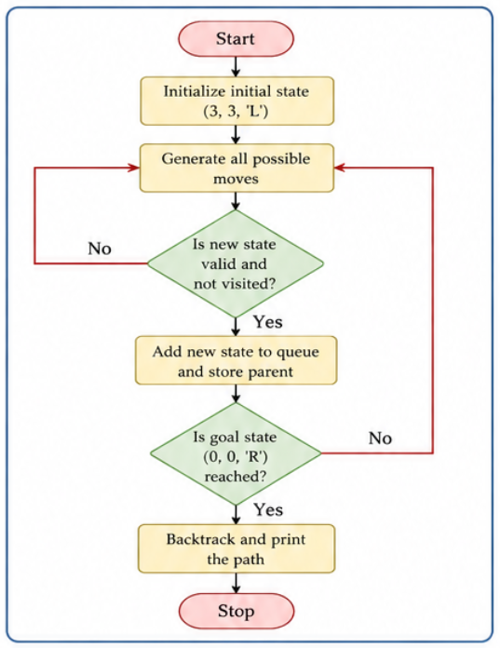
Python Code:
from collections import deque

def valid(state):
m, c, b = state
mr, cr = 3 - m, 3 - c

if not (0 <= m <= 3 and 0 <= c <= 3):
return False

if m > 0 and m < c:
return False

if mr > 0 and mr < cr:
return False

return True

def solve():
start = (3, 3, 'L')
goal = (0, 0, 'R')

moves = [
(-2, 0), (-1, 0), (0, -2),
(0, -1), (-1, -1)
]

queue = deque([start])
parent = {start: None}

while queue:
state = queue.popleft()

if state == goal:
break

m, c, boat = state

for dm, dc in moves:
if boat == 'L':
new_state = (m + dm, c + dc, 'R')
else:
new_state = (m - dm, c - dc, 'L')

if valid(new_state) and new_state not in parent:
parent[new_state] = state
queue.append(new_state)

path = []
state = goal

while state is not None:
path.append(state)
state = parent[state]

path.reverse()

print("Step\tLeft Bank\tBoat\tRight Bank")

for i, (m, c, boat) in enumerate(path):
print(f"{i}\t({m},{c})\t\t{boat}\t({3-m},{3-c})")

solve()
Output:
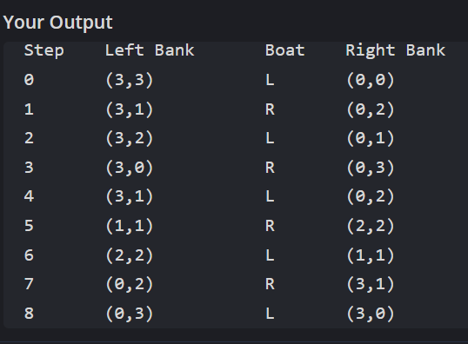

Result
Thus, the Missionaries and Cannibals problem was successfully solved using the Breadth First Search (BFS) algorithm. All 3 missionaries and 3 cannibals were safely transferred from the left bank to the right bank without violating the given constraints.

